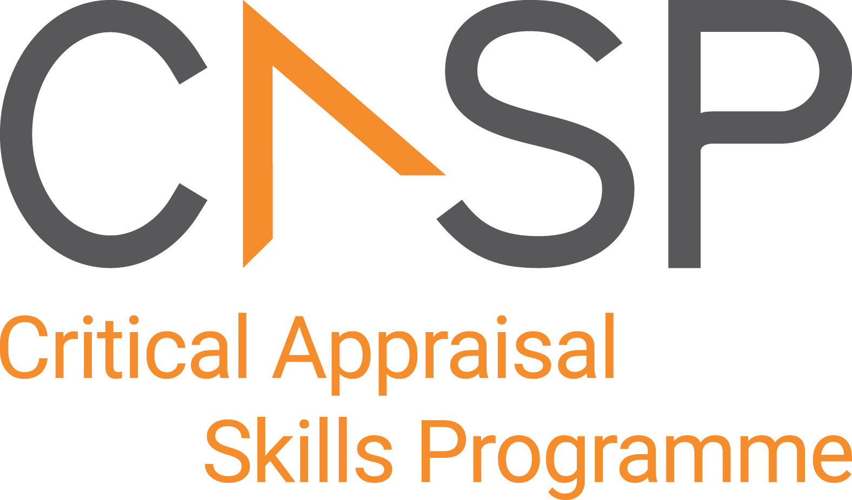
CASP Checklist:
For Randomised Controlled Trials (RCTs)

Reviewer Name: | Lucy Metcalfe
Paper Title: | Hip arthroscopy versus best conservative care for the treatment of femoroacetabular impingement syndrome (UK FASHIoN): a multicentre randomised controlled trial
Author: | Griffin et al., 2018
Web Link:
Appraisal Date:

During critical appraisal, never make assumptions about what the researchers have done. If it is not possible to tell, use the “Can’t tell” response box. If you can’t tell, at best it means the researchers have not been explicit or transparent, but at worst it could mean the researchers have not undertaken a particular task or process. Once you’ve finished the critical appraisal, if there are a large number of “Can’t tell” responses, consider whether the findings of the study are trustworthy and interpret the results with caution.

Section A Is the basic study design valid for a randomised controlled trial?

- Did the study address a clearly formulated research question?  Population: Femoral Acetabular Impingement  Intervention: Hip Arthroscopic  Comparison: Conservative care  Outcome: iHOT-33 at 12 months after randomisation  Secondary: SF-12; EQ-4D-5L at 6 and 12 months post treatment allocation | Yes No Can’t Tell  Outcome measures:  International Hip Outcome Tool – 33 (iHOTT-33)  HRQoL – EQ-5D-5L  SF-12 Health
CONSIDER:
Was the study designed to assess the outcomes of an intervention?
Is the research question ‘formulated’ in terms of:
- Population studied
- Intervention given
- Comparator chosen
- Outcomes measured?

- Was the assignment of participants to interventions randomised?  Randomly assigned (1:1) with a computer generated minimisation (adaptive stratified sampling for centre and type of impingement) | Yes No Can’t Tell
CONSIDER:
- How was randomisation carried out? Was the method appropriate?
- Was randomisation sufficient to eliminate systematic bias?
- Was the allocation sequence concealed from investigators and participants?

- Were all participants who entered the study accounted for at its conclusion?  6208 screened – 5034 not suitable  648 eligible patients  348 participants randomally allocated  171 – hip arthroscopy = 144 (had surgery) intervention  177 = personalised hip therapy = 154 (hip therapy) = 177 intention to treat analysis  Inclusion of intention-to-treat analysis (gold standard)  Intervention: 11 lost to follow up and 3 withdraw (14)  Control: 11 lost to follow up and 4 withdrew (15)  Study was not stopped early! | Yes No Can’t Tell
CONSIDER:
- Were losses to follow-up and exclusions after randomisation accounted for?
- Were participants analysed in the study groups to which they were randomised (intention-to-treat analysis)?
- Was the study stopped early? If so, what was the reason?

Section B Was the study methodologically sound?

- (a) Were the participants ‘blind’ to intervention they were given?  ‘It was not possible to mask patients on the treating clinician to their allocation. Researchers who collected outcome measures and analysed the results were MASKED (blinded) to allocation by concealment of treatment)’  Participants: knew treatment allocation (surgical vs usual care) | Yes No Can’t Tell
(b) Were the investigators ‘blind’ to the intervention they were giving to participants?  ‘It was not possible to mask patients on the treating clinician to their allocation. Researchers who collected outcome measures and analysed the results were MASKED (blinded) to allocation by concealment of treatment)’  Investigators knew treatment allocation (surgical vs usual care) | Yes No Can’t Tell
(c) Were the people assessing/analysing outcome/s ‘blinded’?  Assessor blinded – single blinded | Yes No Can’t Tell
- Were the study groups similar at the start of the randomised controlled trial?  Baseline characteristics: Confounding factors?  - Age: Surgery = 35.4 and Hip therapy = 35.2  - Gender: Surgery = 71 F & 100 M  Hip Therapy = 64 F & 113 M  - Duration of symptoms  - Impingement type  - iHOTT (MICD 6.1 points)  - SF12  - Physical Activity  - Health factors: Diabetes, Smoking | Yes No Can’t Tell
CONSIDER:
- Were the baseline characteristics of each study group (e.g. age, sex, socio-economic group) clearly set out?
- Were there any differences between the study groups that could affect the outcome/s?
- Apart from the experimental intervention, did each study group receive the same level of care (that is, were they treated equally)?  Study protocol: was developed via feasibility study and pilot study – had links to defined study protocol  Intervention: arthroscopic surgery – 27 NHS consultants (surgeons)  Were discharged safely with crutches  Given out patient physiotherapy rehab  Control: personalised hip therapy = best conservative care for FAI: included four components;  - assessment of pain,  - assessment of ROM  - exercise program taught in clinic and repeated at home (individualisation, progression and supervision),  - pain relief (one steroid injection) if pain prevents performance of exercise program  This personalised physiotherapy was given between 6-10 face-face contacts over 12-24 weeks. Some contacts were followed up by either telephone or email when geographical distances prevented face-face contact.  Patients completed exercise diaries.  Appendix:  936 PHT treatment sessions were delivered; 867 (93%) were face to face, 31 (3%) were telephone contacts, 4 (1%) were email contacts, and in 34 (3%) the mode of contact was not recorded. 100 (64%) participants received 6 or more sessions. See Table 1. Treatment sessions lasted a mean of 30 minutes per session (SD = 11 minutes), with the first assessment and treatment session usually lasting longer | Yes No Can’t Tell  Thoughts:  - Both groups received physiotherapy so main difference was surgical intervention  - Personalised physiotherapy (control): required patient motivation, participant, correct performance of exercise  - Pain relief – steroid injection (did they report how many people had steroid)  - Only 64% of participants received 6 sessions of more = 36% received <6 sessions (limited use of physio)?  Baseline data was collected before randomisation  Follow ups: 6 and 12 months from random allocation by postal questionnaire
CONSIDER:
- Was there a clearly defined study protocol?
- If any additional interventions were given (e.g. tests or treatments), were they similar between the study groups?
- Were the follow-up intervals the same for each study group?
Section C: What are the results?

- Were the effects of intervention reported comprehensively?  - Power calculation: We designed this trial to have 90% power to detect an effect of this size at a two sided 5% significant level – allowing for 15% loss to follow up  - Outcome measures: primary iHOT-33  Secondary – 5Q-5D-5L; SF-12  - Expressed via well organised table – showing at 12 months the primary outcome measure iHOTT-33 had a MDI 6.8 points (6.1 MCID) which is <0.0093 (<0.05)  - Yes, this study included both the intention to treat analysis as well as a per protocol analysis comparing participants who received surgery and those who did not.  - Yes – did not report how many people were getting steroids injections as apart of control group  - Yes – there was a report of drop out – the intervention group had 14 drop out and control 15 drop out which are similar  - Did not list any bias – but could be regarding patient expectation? Surgeon bias? As only assessor blinded study  - Mixed effects regression analysis  - All P values reported – 12 months iHOTT 33 was statistically significant  (lower P values = more likley <0.05)  P values reported for both primary and secondary outcomes | Yes No Can’t Tell
CONSIDER:
- Was a power calculation undertaken?
- What outcomes were measured, and were they clearly specified?
- How were the results expressed? For binary outcomes, were relative and absolute effects reported?
- Were the results reported for each outcome in each study group at each follow-up interval?
- Was there any missing or incomplete data?
- Was there differential drop-out between the study groups that could affect the results?
- Were potential sources of bias identified?
- Which statistical tests were used?
- Were p values reported?

- Was the precision of the estimate of the intervention or treatment effect reported?  How reliable the results are – 95% confidence interval – can be 95% sure that the true size of the effect lies within that range  Smaller the range, the more precise results  If they did the study gain 100 x they can be sure the results would land within that number  iHOTT-33:  6 months: -0.7 (-.52 – 3.7)  12 months: 6.8 (1.7 – 12)  Did not reach conclusive results at 6 months but met MCID of 6.1 points at 12 months. | Yes No Can’t Tell
CONSIDER:
- Were confidence intervals (CIs) reported?
- Do the benefits of the experimental intervention outweigh the harms and costs?  The intervention group did met the MCID of 6.1 points – they did highlight the cost effectiveness of the groups saying personalised physiotherapy was more cost effective than surgical intervention.  Harms / unintended effects reported – yes – only one major adverse event = hip joint infection (1) in hip surgery group; 9 superficial wound problems.  Surgical effects: numbness; superficial wound; hip joint infection = surgery comes with superficial and local risk factors compared to physiotherapy  Limitation: Personalised hip therapy group – 72% of participants did not receive the minimum of 6 physiotherapy sessions; 23% of participants did not have progression in the exercise programs; and 4% did not comply with the physiotherapy program  They performed a secondary analysis based on those participants whose treatment was deemed of high fidelity (hip arthroscopy = 105) and personalised hip therapy (=107) the adjusted different was 5.8 (6.1 MCID) favouring intervention * | Yes No Can’t Tell
CONSIDER:
- What was the size of the intervention or treatment effect?
- Were harms or unintended effects reported for each study group?
- Was a cost-effectiveness analysis undertaken? (Cost-effectiveness analysis allows a comparison to be made between different interventions used in the care of the same condition or problem.)
Section D: Will the results help locally?

- Can the results be applied to your local population/in your context?  YES – in physiotherapy – if patients who are struggling with FAI fail conservative therapy – it would be a good idea to send them for an orthopaedic review (if able) as we know that there was a statistically significant improvement in symptoms with the iHOTT-33 at 12 months post intervention.  FAI is a common, MSK condition presenting to physiotherapy, the control group was individualised best practiced physiotherapy which is what we provide as autonomous professionals.  The study baseline characteristics represented a similar characteristic to those in the NHS / private population  It would have been useful to know how many people received physiotherapy + injection as this could be a useful adjunct if surgery if not available.  The iHOTT-33 would be a useful outcome measure to use in this population when they present to physiotherapy  Consider 6 sessions of physiotherapy, if nil improvement consider referral for surgical intervention. | Yes No Can’t Tell
CONSIDER:
- Are the study participants similar to the people in your care?
- Would any differences between your population and the study participants alter the outcomes reported in the study?
- Are the outcomes important to your population?
- Are there any outcomes you would have wanted information on that have not been studied or reported?
- Are there any limitations of the study that would affect your decision?
- Would the experimental intervention provide greater value to the people in your care than any of the existing interventions?  Considering we are physiotherapist and not surgeons, it is useful to see a physiotherapy control group measured against surgical intervention.  However, the surgical intervention outweighed the control physiotherapy intervention.  Considering training needs; physiotherapy would be a good first line application to treatment of FAI, if nil improvement in 1 year – intervention could be a good option for those failing.  Due to the cost effectiveness of physiotherapy comparative to surgical – physiotherapy would be a good first line intervention.  Given that physiotherapy is aimed to improve muscle control, strength around the hip and movement patterns and surgical is to reshape the bone to prevent impingement; both groups received physiotherapy shows there is efficacy in proving physiotherapy to patients with FAI. | Yes No Can’t Tell
CONSIDER:
- What resources are needed to introduce this intervention taking into account time, finances, and skills development or training needs?
- Are you able to disinvest resources in one or more existing interventions in order to be able to re-invest in the new intervention?

APPRAISAL SUMMARY: List key points from your critical appraisal that need to be considered when assessing the validity of the results and their usefulness in decision-making.
Positive/Methodologically sound | Negative/Relatively poor methodology | Unknowns
This study – using the CASP is methodological sound.

Referencing recommendation:

CASP recommends using the Harvard style referencing, which is an author/date method. Sources are cited within the body of your assignment by giving the name of the author(s) followed by the date of publication. All other details about the publication are given in the list of references or bibliography at the end.

Example:

Critical Appraisal Skills Programme (2024). CASP (insert name of checklist i.e. randomised controlled trials (RCTs) Checklist.) [online] Available at: insert URL. Accessed: insert date accessed.

Creative Commons

©CASP this work is licensed under the Creative Commons Attribution – Non-Commercial- Share A like. To view a copy of this licence, visit https://creativecommons.org/licenses/by-nc-sa/4.0/


Need further training on evidence-based decision making? Our online training courses are helpful for healthcare educational researchers and any other learners who:

- Need to critically appraise and stay abreast of the healthcare research literature as part of their clinical duties.
- Are considering carrying out research & developing their own research projects.
- Make decisions in their role, whether that be policy making or patient facing.

Benefits of CASP Training:

- Affordable – courses start from as little as £6
- Professional training – leading experts in critical appraisal training
- Self-directed study – complete each course in your own time
- 12 months access – revisit areas you aren’t sure of and revise
- CPD certification - after each completed module

Scan the QR code below or visit https://casp-uk.net/critical-appraisal-online-training-courses/ for more information and to start learning more.

